Interactive Lessons # 4 – Magnetic Fields and Faraday’s Law
Calculus Physics 2

We will be using the University of Colorado’s physics simulations called PhET interactive simulations in Physics

Go to the link below

https://phet.colorado.edu/sims/cheerpj/faraday/latest/faraday.html?simulation=faraday


If the link does not work Google or Chrome: PhET and select “Faraday’s Electromagnetic Lab”.

You may have to check “Java via CheepJ” to find “Faraday’s Electromagnetic Lab”.

Learning Objectives

- Explore the magnetic field around a permnate magnet and a current carrying coil of wire.
- Decribe mutual inductance and how it relates to EMI.
- Explain how a changing magnetic flux induces an emf in a coil.
- Describe the relationship between magnetic field strength and induced current.
- Predict the direction of the induced current using Lenz's Law.
- Investigate how the speed of magnetic field changes affects the induced emf.
- Relate observations from the simulation to Faraday's Law:

Part I - Understanding the Bar magnet

- Use the “Bar Magnet” tab.
- The magnet and compass can be moved by clicking and holding on the object with your mouse.
- Magnetic Field Strength meter can be activated by clicking the “Show Field meter” in the control box.

- The compass is a magnet that is able to rotate in the magnet field, for the compass in the simulation, what magnetic pole is the red tip? Explain how you know this.

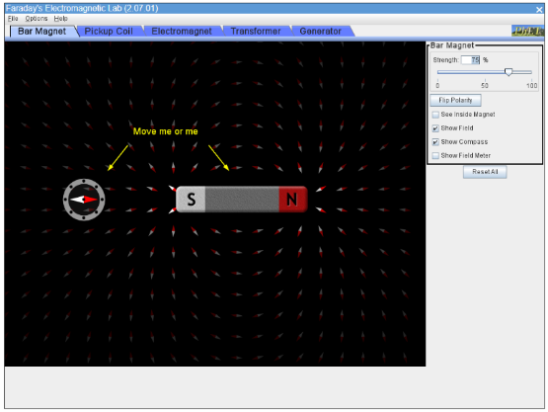

Magnetic field around a bar magnet

Move the compass to the 4 positions indicated below keeping the bar magnet’s position fixed.

- When the compass is directly to the right of the magnet, what direction is the red tip pointing, explain why?
N
S
above
right
left
below

- When the compass is directly above the magnet, what direction is the red tip pointing, explain why?

- When the compass is directly to the left of the magnet, what direction is the red tip pointing, explain why?

- When the compass is directly below the magnet, what direction is the red tip pointing, explain why?

- From what pole do the magnetic field lines come out of and what pole do the magnetic field lines go into for the field external to the bar magnet?

- Inside the magnet what direction are the field lines?

- When the polarity of the magnet is flipped what happens to the compass direction and field lines?

The Magnetic Field is a Vector

- Click on “Show Field Meter” and mathematically demonstrate that the components of the magnetic field given by the meter (B_{x} and B_{y}) are equal to the magnitude of the magnetic field vector $\vec{B}$ at that point. Use the approximate points shown in the diagram below Show all work!

Positions to measure field Magnetic field meter
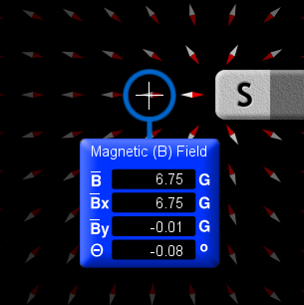
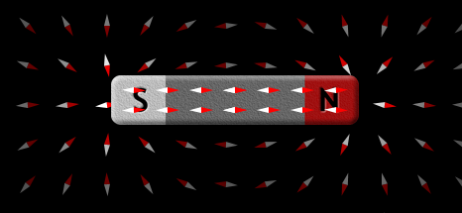
A
B

$$\left|\vec{B}\right|=\sqrt{B_{x}^{2}+B_{y}^{2}}$$

- Is the magnetic field a vector. explain.

Part II - Understanding the Electromagnet

- Use the “Electromagnet” tab for this experiment.
- The control box in the upper right corner will control the electromagnet properties.
- Always use the “DC” battery for this part of the experiment.

With the voltage of the battery at 10V to the right (default setting) move the compass around the coil of wire and indicate the direction of the red tip
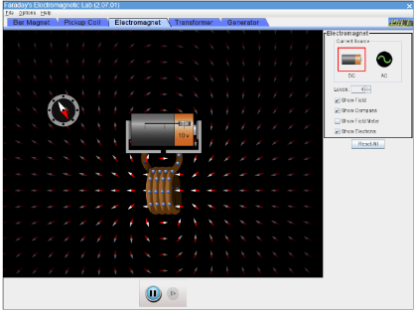
- The Compass directly to the right of the coil?

- The Compass directly to the left of the coil?

- Which side of the coil would be considered the “North magnetic pole” of the coil and which side is the “South magnetic pole” of the magnet?

- What happens to the Magnetic field when the voltage is set to zero, explain why?

- What happen to the direction of the magnetic field when the polarity of the voltage is reversed (move voltage to the left)?

- How is the magnetic field generated by a coil of current carrying wire similar to a bar magnet’s magnetic field?

- Explain from the simulation that the righthand rule # 2 for determining the magnetic field direction from current flow is valid using the positive potential and the current flow, then the negative potential and the new direction of current flow.

Part III - Understanding the Transformer (Mutual Inductance)

Click on the “Transformer” tab
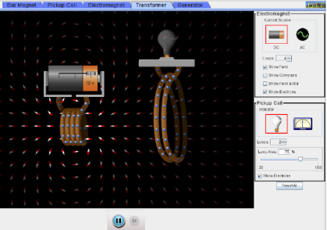
- With the dc source selected, move the batter/coil next to the light bulb coil, once the battery is next to the light bulb, describe the current in the light bulb coil as you moved the coil and then when it had stopped.

- Change the dc source to the ac source, describe the current in the light bulb coil,

- Add coils to the light bulb circuit and increase the area to maximum, how does this change the current in the light bulb
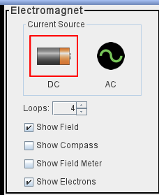

- Explain this affect using Faradays law

Part IV - Understanding Faraday’s Law (Different PHet Simulation)
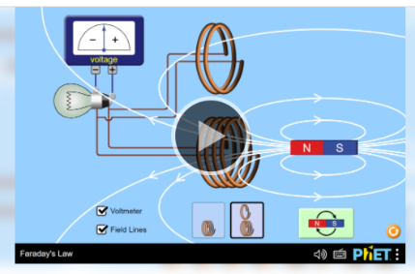
Go to the link below
Faraday's Law‬ (colorado.edu)‬‬‬‬‬

If the link does not work Google or Chrome: PhET and select “Faraday’s Law”.

Set up the coil with the voltmeter and field lines showing as shown.
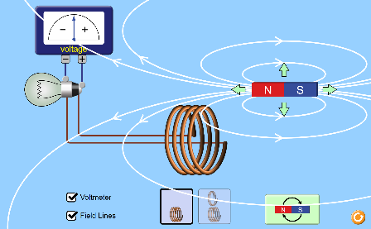
Assume that
- Positive charge going into the positive terminal of the meter creates a positive current.
- Positive charge going into the negative terminal of the meter creates a negative current.

- With the magnet at the right of the coil and aligned horizontal with the coil, move the magnet slowly towards the coil. Move the magnet back to the right and then move it towards the coil very fast. Describe what happens to the voltage from the slow and fast movement.

- Predict using the right-hand rule # 2 and Faraday’s Law, what direction the current should go (+ or -) as the magnetic field inside the coil gets stronger and is pointing from right to left.

- Verify your prediction, start with the magnet on the far-right side and move it slowly towards the coil but do not go through the coil. What direction is the current flow on the meter

- Predict using the right-hand rule what direction the current should go (+ or -) as the magnetic field inside the coil gets weaker and is pointing from right to left

- Verify your prediction, start with the magnet next to the right side of the coil and move it slowly away from the coil moving horizontally to the right.

- Start with the magnet on the right side and move it through the coil to the far left, describe what happens to the current direction and brightness of the bulb as it is moving in the region

- on the right side

- in the coil

3) moving on the left side

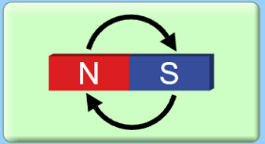
- Move the magnet to the center of the coil of wire, flip the poles of the magnet by click on the flip tab, describe what happens for two flips.

- Move the magnet outside the coil and flip the poles two time, how is this different than the one with the magnet in the coil, explain why this would be the case.

- In 3-5 complete sentences, summarize the factors that affect electromagnetic induction and explain how Faraday's Law and Lenz's Law were demonstrated in the simulation.

- When complete Upload this Lesson to this assignment

